Arkansas State University
Red WOLF Center
Reservation Information &
Application Form

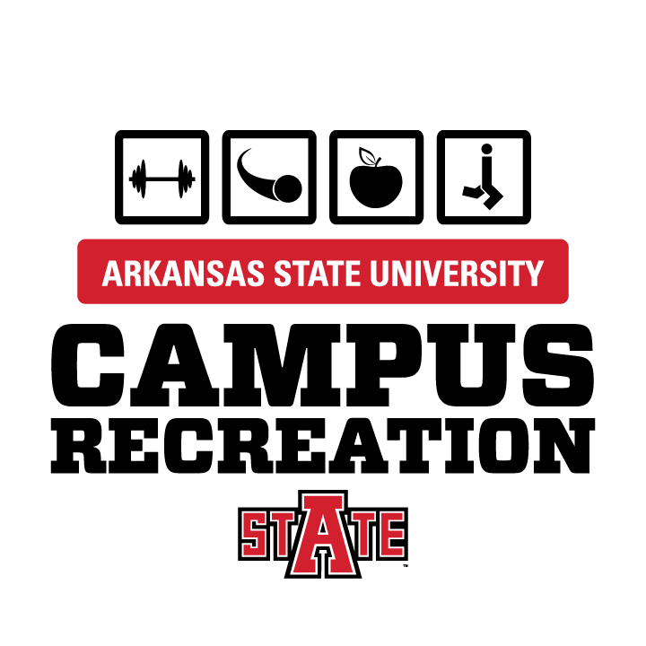

Campus Recreation * Red WOLF Center, room 104 * (870) 972-3800 * www.astate.edu/a/campusrecreation

Reservation Procedure:
- Request a reservation by completing the appropriate Facility Application Form and submit to the Red WOLF Center, room 104. All information requested must be complete, including event description, equipment needed, signatures, etc. before reservation requests may be considered.
- Applicants will typically be notified within 2 business days of approval or denial of application.
- If approved, applicant must submit appropriate fees ($50 non-refundable deposit and/or full payment) within 3 business days.
- RESERVATIONS ARE NOT CONFIRMED UNTIL DEPOSIT AND FEES (IF APPLICABLE) HAVE BEEN PAID
- All reservations must be paid in full at least 5 business days in advance prior to event date. Reservation requests submitted less than 5 business days prior to event will require payment in full, upon approval of application. No reservations will be made the day of the event.
- Cancellation policy:
More than 5 business days: 100% refund (less non-refundable deposit)
3-4 business days: 75% refund (less non-refundable deposit)
Less than 3 business days: 50% refund (less non-refundable deposit)
Less than 1 business day: NO REFUND
- Campus Recreation reserves the right to cancel a reservation or deny a reservation for abuse of facility rules and regulations.
- Any changes to approved reservations will need to be made as soon as possible.

Usage Fees:
The following fees will be charged for the use of Red WOLF Center facilities.

Climbing Wall Only
Facility Hours 7:30a – 11:00p
Pricing includes 2 attendants

2 hour $100
3 hours $150
4 hours $200

Recommended: 1 attendant per 10 climbers
Pricing available for additional attendants/per hour
Base Facility Rental Rates
Facility Hours 7:30a –11:00p
2 hour minimum
ASU RATE
Full Day / Facility $600 / Day
Up to 5 hours $350 / Day
1 space $40 / Hour
2 spaces $75 / Hour
Overnight Rates Ask for quote
Overtime Rates $50 / hour

Rates Do NOT include climbing wall or cardio room

Facility Guidelines:

- All groups sponsoring any activity on Arkansas State University property must comply with all University policies and regulations, as well as with any applicable federal, state, and local laws.
- Per University policy, outside food and drink is not permitted; all food and drink must be purchased from Sodexo Catering; to be arranged 10 days prior to event.
- All normal ASU Red WOLF Center rules and regulations must be followed and will be enforced.
- NO Alcoholic Beverages, Tobacco, or other illegal substances are permitted on premises.
- Customer is responsible for any excess trash removal. Additional charges may be accessed for facility cleaning and trash removal if needed.
- All attendees must provide valid ASU ID for admittance to event or function or purchase guest pass for $3 when event is held during regular business hours.

Removal of Objectionable Persons:
ASU reserves the right to remove any objectionable person(s) from the facility. If that person or persons is/are affiliated with your event, you may be held responsible for damage incurred from such removal.

Release of All claims and Indemnity and Hold Harmless Agreement
The Customer assumes all risks of personal injury, property damage, or other loss sustained by any person attending or participating in any way with the event. Customer releases Arkansas State University, its employees, officers, and agents from any and all claims for personal injury, property damage, or other loss which may occur in association with this event. Customer accepts full responsibility for organizing, supervising, and conducting all activities associated with this event, Customer agrees to indemnity and hold harmless Arkansas State University, its employees, officers and agents from any and all losses, costs, causes of action, claims, for damages to either person or property that relate to or arise from any activities connected to this event. The Customer shall indemnify and save harmless ASU and its agents and employees from damage, loss, expense, action or cause of action, including reasonable attorney’s fees, arising from or made by any person or persons the Customer may hire, employ, or subcontract for any purpose. It is further understood and agreed that if the Customer hires any employees or subcontractors to perform work for the Customer in connection with the event, the Customer shall take such action at Customer’s sole risk, expense, and liability and Customer further hereby assumes all liability for any negligent act or omission or intentional act by such employee or subcontractor.

Non-discrimination Policy:
During the entirety of this agreement, the parties will not discriminate against any person on the basis of race, color, religion, national origin, sex, age, disability, veteran, “or other legally protected status”.

Advertising
Promotional Materials for University-sponsored and co-sponsored events must give appropriate credit to the University. All advertising and promotional materials of the Customer should clearly state that sponsorship of the event resides with the organization. All documents must list phone numbers of the Customer responsible for the event. The Customer agrees to assume full responsibility for complying with the federal copyright laws.


FACILITY RESERVATION
APPLICATION

Name of Organization ______________________________________________________________________________

Name of Applicant _____________________________________ ASU ID/DL ________________________________

E-mail ______________________________________________ Phone ___________________________________

Alternate Contact _____________________________________ Phone ___________________________________

Organizational Advisor _________________________________ Phone ___________________________________

Name of Event _____________________________________ Estimated Attendance ________________________

Date(s) Requested __________________________________ Time ___________ AM / PM to __________ AM / PM

(Include set-up and clean up times)
Space(s) Request:
Court “A” _______ Court “S” _______ Court “U” ________ MAC Gym _______
Group Fitness Room ____________ Conference Room _________ Lobby __________
Rock Wall ______________ SAC (Student Activity Center) ______________

ASU Catering Services: YES NO (If yes, contact Sodexo Catering 972-3859)

Detailed Description of Event (including activities planned, anticipated attendees, etc.)

Detailed Description of Set-Up (including tables, chairs, electronic equipment, etc.)

I have read and understand the reservation procedures and facility use policies and agree to comply with all written and posted policies of Campus Recreation.

Applicant’s Signature _______________________________________________ Date ______________________

Advisor’s Signature _________________________________________________ Date ______________________

Questions: Contact Carol Cummings @ 972-3800

FOR OFFICE USE ONLY
Date Received _______________ Facility Rate $ ________________ X _______________ = _______________

Reservation Approved ________ Additional Fees _________________________________ = _______________

Reservation Denied ________ _________________________________ = _______________

Total Fees = _______________

Payment Received _______________
Campus Recreation Rep. ________________________________________________ Date ________________________

